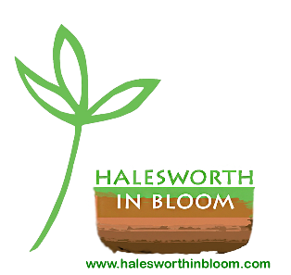**HALESWORTH IN BLOOM**

**2024 AGM**

**HIB ORGANISATION**

**PROJECT AREAS AND COORDINATORS/VOLUNTEERS**

* **Tuesday Work Party** – Town Park, Thoroughfare planters, Wherry bed in Town Park, Station Road planters, weeding in the Thoroughfare, Sorting Office planters, Hooker House planters, roundabouts

Stephanie Hammond, Gillian Coulson, Reuben Perkins, Anthea Warne, Maggie Wisniewski and Bramfield House

* Memorial Garden – Lisa Simmonds, Maggie Wisniewski
* Middle car park – Lisa Simmonds, Alan Witherby
* London Road recesses – Chas Keyes
* Town Sign planters – Sue Bullough (north), Bramfield House (south)
* Tiered planter (Market Place) – Chas Keyes
* New Cut – Chas Keyes
* Hooker House basket on the wall – Chas Keyes
* Herb Garden (opposite the Library)– Anthea Warne
* Tamsyn’s Memorial Bed – Anthea Warne, Stephanie Hammond
* Triple Plea roundabout – Karen Austin, Reuben Perkins
* Tree Warden – Lisa Simmonds
* Watering – All of the above!

**STEERING GROUP**

* Stephanie Hammond – Projects and Liaison Planning Officer & Public Relations Officer
* Liz Wooster – Treasurer
* Gillian Coulson – Secretary
* Steph Minns – Digital Media Officer

**COMMITTEE**

Steering Group plus Lisa Simmonds, Maggie Wisniewski and Anthea Warne